

Capstone Project Report
Report 3 – Software Requirement Specification

– Ho Chi Minh City, October 2025 –
Table of Contents
I. Record of Changes 3
II. Software Requirement Specification 4
1. Product Overview 4
2. User Requirements 5
2.1 Actors 5
2.2 Use Case 5
2.2.1 Use Case Diagram 5
2.2.2 Descriptions 7
3. Functional Requirements 13
3.1 System Functional Overview 13
3.1.1 Screens Flow 13
3.1.1.1 Admin Flow 13
3.1.1.2 Trainee Flow 14
3.1.1.2 Instructor Flow 14
3.1.1.2 Simulation Manager Flow 15
3.1.2 Screen Descriptions 15
3.1.3 Screen Authorization 17
3.1.4 Non-Screen Functions 19
3.1.5 Entity Relationship Diagram 20
3.1.6 Entity Relationship Description 20
3.2 Feature 1: Trainee Learning & Progress Tracking 23
3.3 Feature 2: Trainee Simulation Practice 25
3.4 Feature 3: Program & Course Management 27
3.5 Feature 4: Trainee Final Examination 29
4. Non-Functional Requirements 31
4.1 Security 31
4.2 Performance & Scalability 32
4.3 Interoperability & Compatibility 32
4.4 Availability & Reliability 32
5. Business Rules 32

I. Record of Changes
Date | A*  M, D | In charge | Change Description
28/10/2025 | A | Duong Minh Nhat | Adding document
10/11/2025 | M | Duong Minh Nhat | Updating document
01/12/2025 | M | Duong Minh Nhat | Reviewing and updating document
*A - Added M - Modified D - Deleted

II. Software Requirement Specification

1. Product Overview
The Learner Management and 3D Simulation System for Crane Training Center (LSSCTC) is an integrated software suite designed to address the high costs, significant safety risks, and logistical challenges of traditional crane operation training. The system provides a unified solution for both theoretical and simulated practical training.

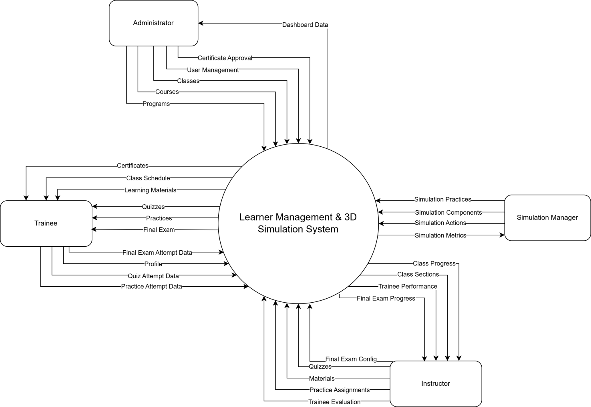

2. User Requirements

2.1 Actors
# | Actor | Description
1 | Administrator | The Administrator is the top-level user responsible for the overall system setup and user management. Using the web application, they manage all user accounts, create and organize the academic structure by managing programs, courses, and classes.
2 | Simulation Manager | The Simulation Manager is responsible for defining all aspects of the 3D simulation content. They manage the simulation practices, including simulation components, actions , and warnings.
3 | Instructor | The Instructor is responsible for managing the content and trainees within their assigned classes. Using the web application, they manage class members, organize class sections, and upload learning materials and quizzes. They also assign simulation practices to the class and are responsible for tracking trainee results, providing feedback , and confirming the final status for each trainee.
4 | Trainee | The Trainee is the primary learner in the system. They use the web application to manage their profile, enroll in classes, access learning materials, and complete theoretical quizzes. They also use the separate 3D simulation desktop application to log in and perform practical crane simulation exercises.

2.2 Use Case

2.2.1 Use Case Diagram

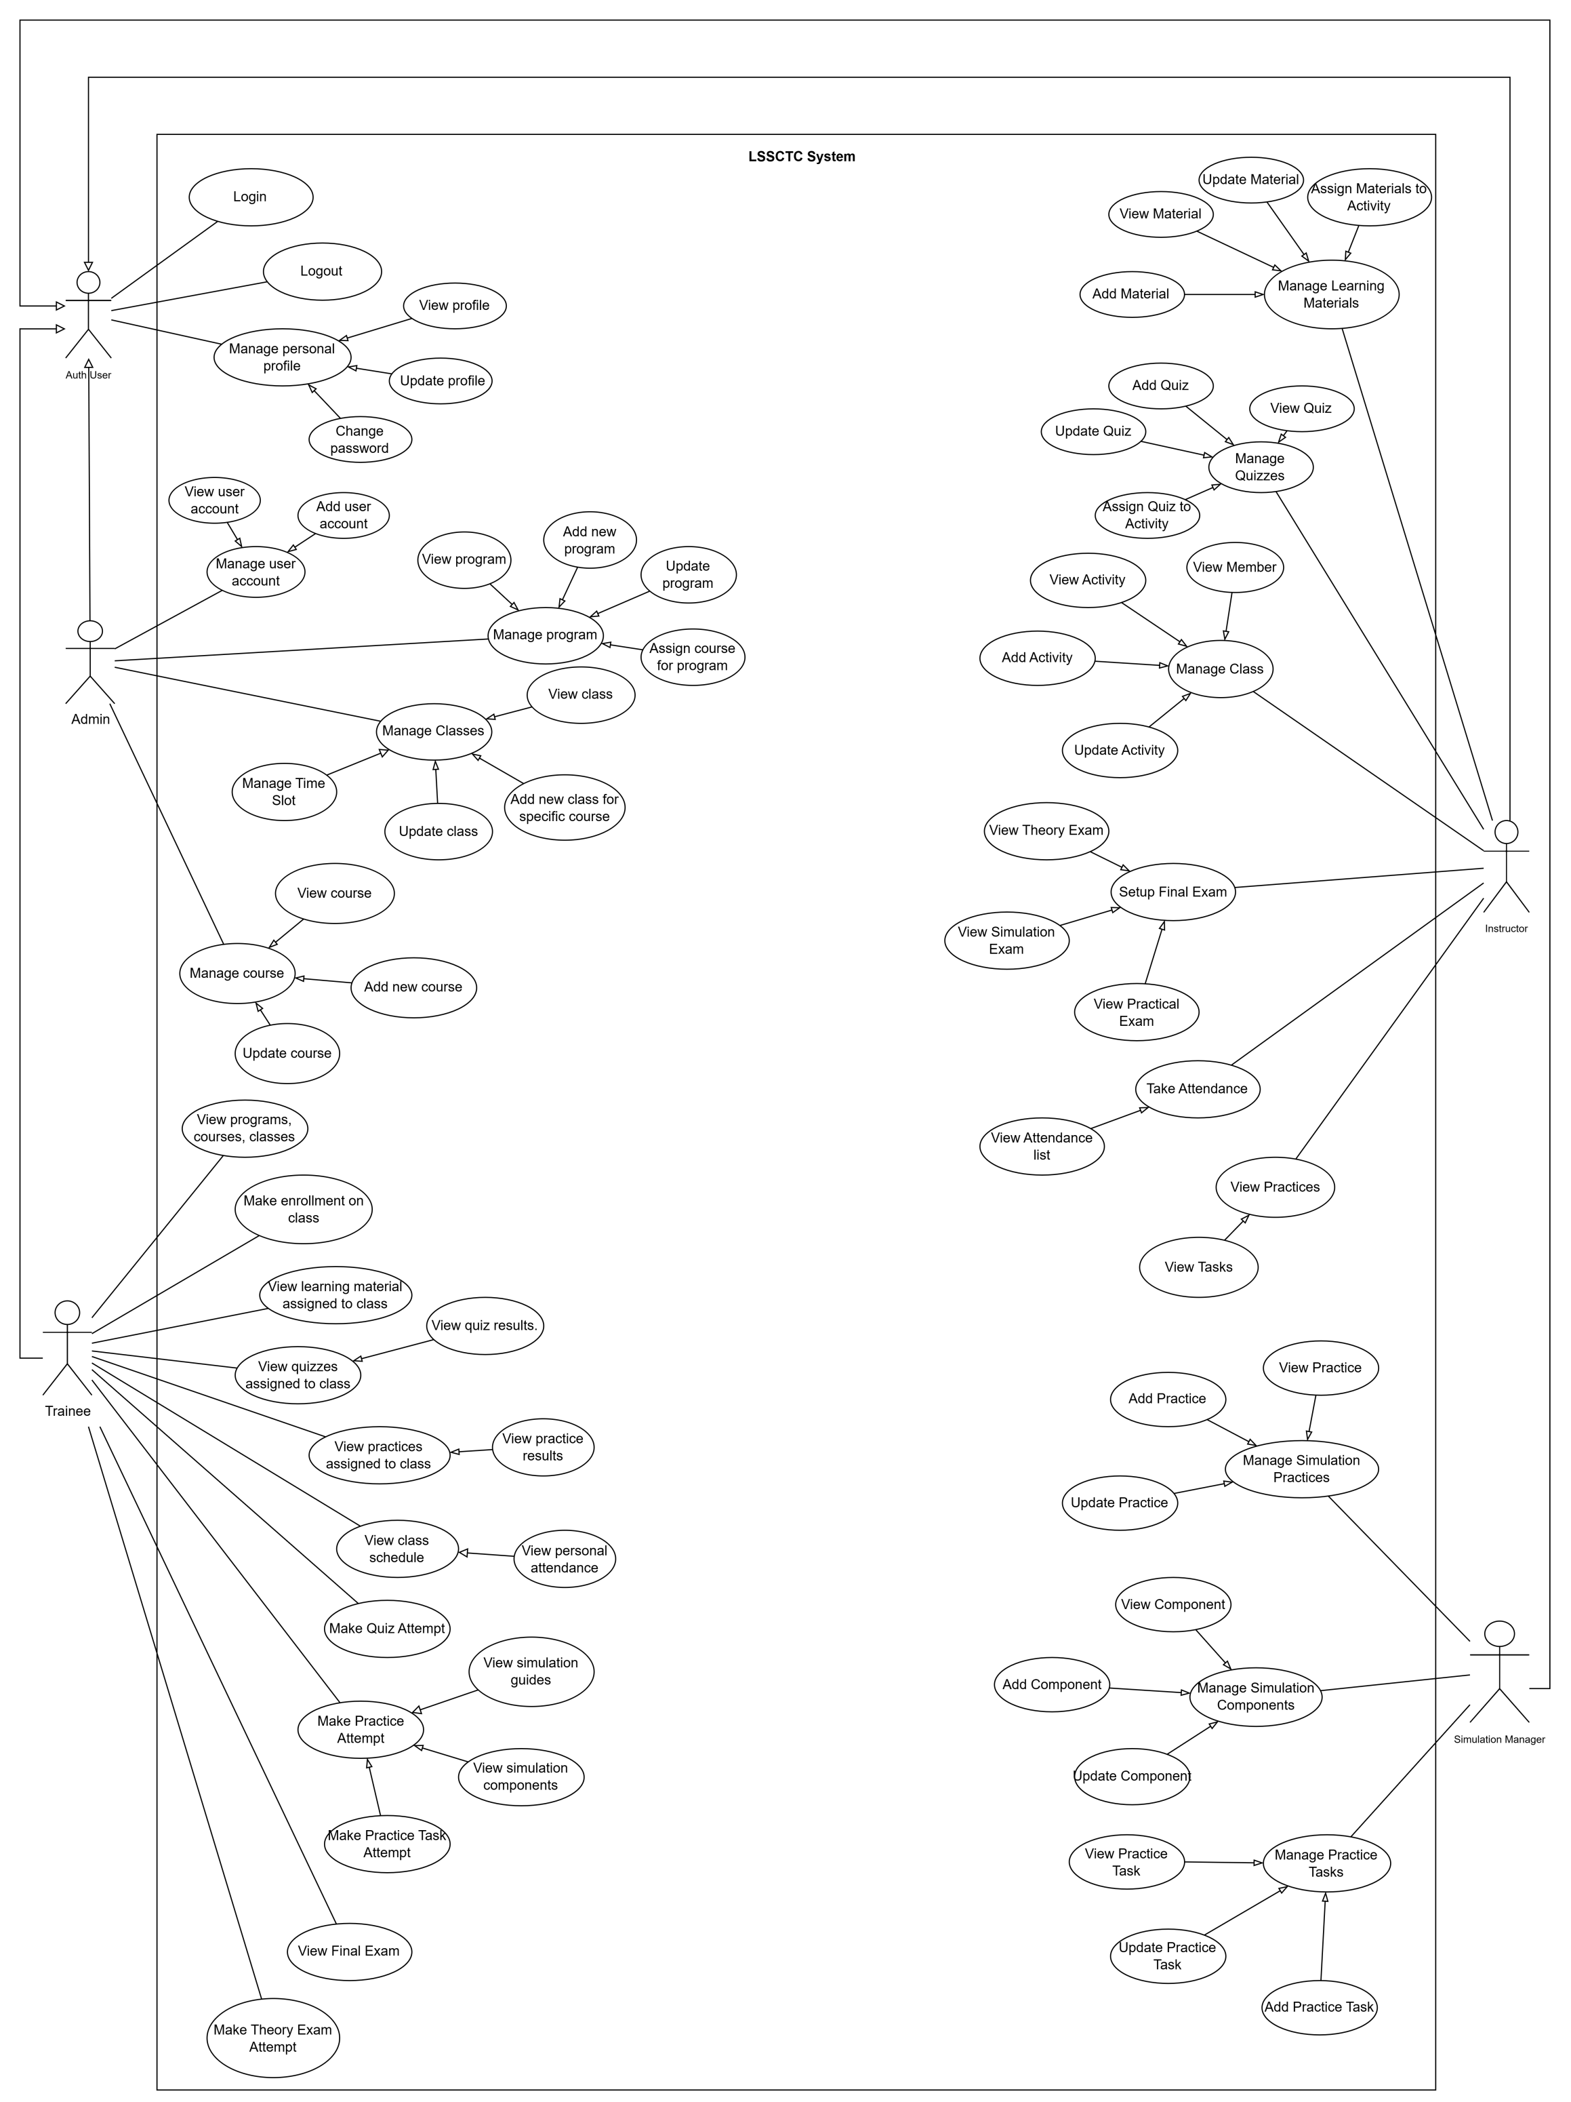

2.2.2 Descriptions
ID | Use Case | Actors | Use Case Description
UC-01 | Add Material | Instructor | This feature allows instructor add a new learning material (PDF, video, link) for teaching.
UC-02 | Update Material | Instructor | This feature allows instructor update an existing learning material’s info or file.
UC-03 | View Material | Instructor | This feature allows instructor view the list and details of learning materials.
UC-04 | Assign Materials to Section | Instructor | This feature allows instructor link selected materials to a section/partition for trainees to access.
UC-05 | Add Quiz | Instructor | This feature allows instructor create a new quiz with basic information.
UC-06 | Update Quiz | Instructor | This feature allows instructor edit a quiz’s information.
UC-07 | View Quiz | Instructor | This feature allows instructor view quizzes and their details.
UC-08 | Assign Quiz to Section | Instructor | This feature allows instructor attach a quiz to a specific section/partition for delivery.
UC-09 | Add Member | Instructor | This feature allows instructor add a trainee to the class roster.
UC-10 | View Member | Instructor | This feature allows instructor view trainee profiles and class membership.
UC-11 | Track Member Process | Instructor | This feature allows instructor track each trainee’s study progress and results.
UC-12 | View Section | Instructor | This feature allows instructor track each trainee’s study progress and results.
UC-13 | Add Section | Instructor | This feature allows instructor create a new section for the class.
UC-14 | Update Section | Instructor | This feature allows instructor edit section information.
UC-15 | Assign Practices to Section | Instructor | This feature allows instructor link practice activities to a section/partition.
UC-16 | View Practices | Instructor | This feature allows instructor view practice list and details in the class/section.
UC-17 | Confirm Pass/Fail Results | Instructor | This feature allows instructor view practice list and details in the class/section.
UC-18 | Add Practice | Instructor | This feature allows instructor create a new practice activity.
UC-19 | Update Practice | Instructor | This feature allows instructor edit an existing practice activity.
UC-20 | View Practices | Instructor | This feature allows instructor view details of a specific practice activity.
UC-21 | Add Component | Instructor | This feature allows instructor add a simulation component needed for practice.
UC-22 | Update Component | Instructor | This feature allows instructor update a simulation component’s information.
UC-23 | View Component | Instructor | This feature allows instructor view the list and details of simulation components.
UC-24 | Add Action | Instructor | This feature allows instructor add a simulation action/step used in practices.
UC-25 | Update Action | Instructor | This feature allows instructor update a simulation action/step.
UC-26 | View Action | Instructor | This feature allows instructor view the list and details of simulation actions.
UC-27 | Add Component | Simulation Manager | This feature allows the simulation manager to add a new simulation component to the system.
UC-28 | Update Component | Simulation Manager | This feature allows the simulation manager to edit or update existing simulation component information.
UC-29 | View Component | Simulation Manager | This feature allows the simulation manager to view the list and details of simulation components.
UC-30 | Add Action | Simulation Manager | This feature allows the simulation manager to add a new simulation action used in training practices.
UC-31 | Update Action | Simulation Manager | This feature allows the simulation manager to edit or update existing simulation actions.
UC-32 | View Action | Simulation Manager | This feature allows the simulation manager to view the list and details of simulation actions.
UC-33 | Add Slot | Simulation Manager | This feature allows the simulation manager to create a new simulation timeslot for scheduling practices.
UC-34 | Update Slot | Simulation Manager | This feature allows the simulation manager to update or reschedule an existing simulation timeslot.
UC-35 | View Slot | Simulation Manager | This feature allows the simulation manager to view all simulation timeslots and their details.
UC-36 | Assign Practice to Slot | Simulation Manager | This feature allows the simulation manager to assign a specific practice activity to a simulation timeslot.
UC-37 | Add Practice Step | Simulation Manager | This feature allows the simulation manager to define and add new steps for a practice scenario.
UC-38 | Update Practice Step | Simulation Manager | This feature allows the simulation manager to modify or reorder steps within a practice scenario.
UC-39 | View Practice Step | Simulation Manager | This feature allows the simulation manager to view practice steps assigned to each practice activity.
UC-40 | Add Warning | Simulation Manager | This feature allows the simulation manager to create new warning messages or alerts for simulation steps.
UC-41 | Update Warning | Simulation Manager | This feature allows the simulation manager to modify or remove existing simulation warnings.
UC-42 | View Warning | Simulation Manager | This feature allows the simulation manager to view all defined warnings and their details.
UC-43 | Make enrollment programs/courses/classes | Trainee | This feature allows trainee submit an enrollment request to a program, course, or class.
UC-44 | View programs, courses, classes | Trainee | This feature allows trainee view the catalog and details of available programs, courses, and classes.
UC-45 | Access learning material | Trainee | This feature allows trainee access learning materials provided for their study.
UC-46 | View learning material assigned to class section | Trainee | This feature allows trainee view materials specifically assigned to their class section.
UC-47 | Download material | Trainee | This feature allows trainee download learning files for offline use.
UC-48 | View quizzes assigned to class section | Trainee | This feature allows trainee see newly assigned quizzes for their section.
UC-49 | Make attempt quizzes | Trainee | This feature allows trainee start and submit a quiz attempt.
UC-50 | View recorded results | Trainee | This feature allows trainee view their quiz scores and attempt history.
UC-51 | View practices assigned to class section | Trainee | This feature allows trainee view the list of practices assigned to their section.
UC-52 | Select a practice to make a new attempt | Trainee | This feature allows trainee choose a practice and create a new attempt.
UC-53 | View list practices | Trainee | This feature allows trainee browse the practice list available to them.
UC-54 | Settings simulation guides | Trainee | This feature allows trainee configure guidance options and hints for simulation.
UC-55 | View simulation guides | Trainee | This feature allows trainee read the simulation guidance before or during practice.
UC-56 | View practice steps and step details | Trainee | This feature allows trainee review each step and its detailed instructions.
UC-57 | View simulation components | Trainee | This feature allows trainee view components used in the simulation scenario.
UC-58 | Perform simulation actions | Trainee | This feature allows trainee perform the required actions in the simulator.
UC-59 | View post-practice result | Trainee | This feature allows trainee see overall results after completing a practice.
UC-60 | View step result and warning message | Trainee | This feature allows trainee check each step’s result and any warning messages.
UC-61 | View user account | Admin | This feature allows admin view the list and details of user accounts in the system.
UC-62 | Add user account | Admin | This feature allows admin create a new user account and assign a role.
UC-63 | Deactivate user account | Admin | This feature allows admin deactivate or disable a user account.
UC-64 | Manage user account | Admin | This feature allows admin manage all user accounts, including creating, viewing, and deactivating users.
UC-65 | View program | Admin | This feature allows admin view the list and details of existing training programs.
UC-66 | Add new program | Admin | This feature allows admin create a new training program in the system.
UC-67 | Update program | Admin | This feature allows admin edit information of an existing training program.
UC-68 | Assign course for program | Admin | This feature allows admin assign specific courses to a training program.
UC-69 | Manage program | Admin | This feature allows admin manage all training programs, including viewing, updating, and course assignment.
UC-70 | View class | Admin | This feature allows admin view the list and details of all classes in the system.
UC-71 | Add new class for specific course | Admin | This feature allows admin create a new class linked to a selected course.
UC-72 | Update class | Admin | This feature allows admin modify class information such as schedule or instructor.
UC-73 | Manage classes | Admin | This feature allows admin manage all classes, including creating, updating, and viewing them.
UC-74 | View course | Admin | This feature allows admin view the list and details of all courses in the system.
UC-75 | Add new course | Admin | This feature allows admin create a new course record in the system.
UC-76 | Update course | Admin | This feature allows admin edit the details of an existing course.
UC-77 | Manage course | Admin | This feature allows admin manage all courses, including adding, updating, and viewing them.
UC-78 | View programs, courses, classes | Admin | This feature allows admin view an overview list of all programs, courses, and classes in the system.
UC-79 | Login | Auth User | This feature allows user login to the system by verifying their credentials and accessing authorized functions.
UC-80 | Logout | Auth User | This feature allows user logout from the system securely and end their session.
UC-81 | View profile | Auth User | This feature allows user view their personal profile information stored in the system.
UC-82 | Update profile | Auth User | This feature allows user edit and update their personal profile details.
UC-83 | Change password | Auth User | This feature allows user change their password for account security.
UC-84 | Manage personal profile | Auth User | This feature allows user manage their personal profile, including viewing, editing, and changing password.

3. Functional Requirements

3.1 System Functional Overview

3.1.1 Screens Flow

3.1.1.1 Admin Flow
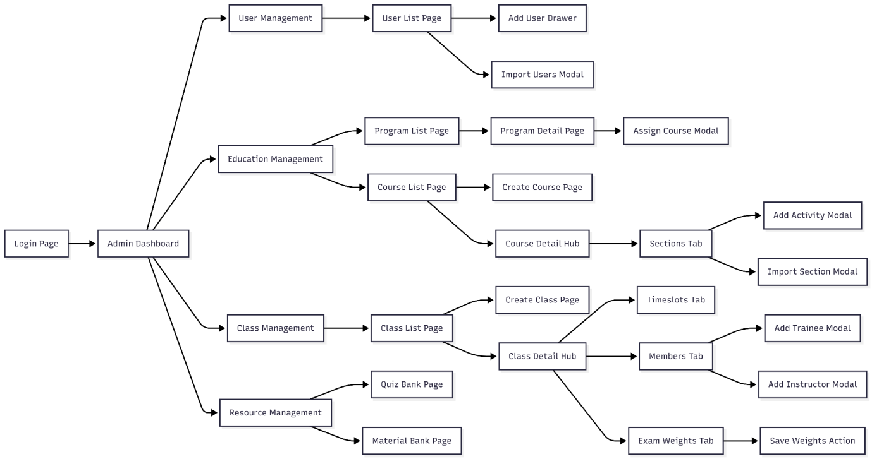

3.1.1.2 Trainee Flow
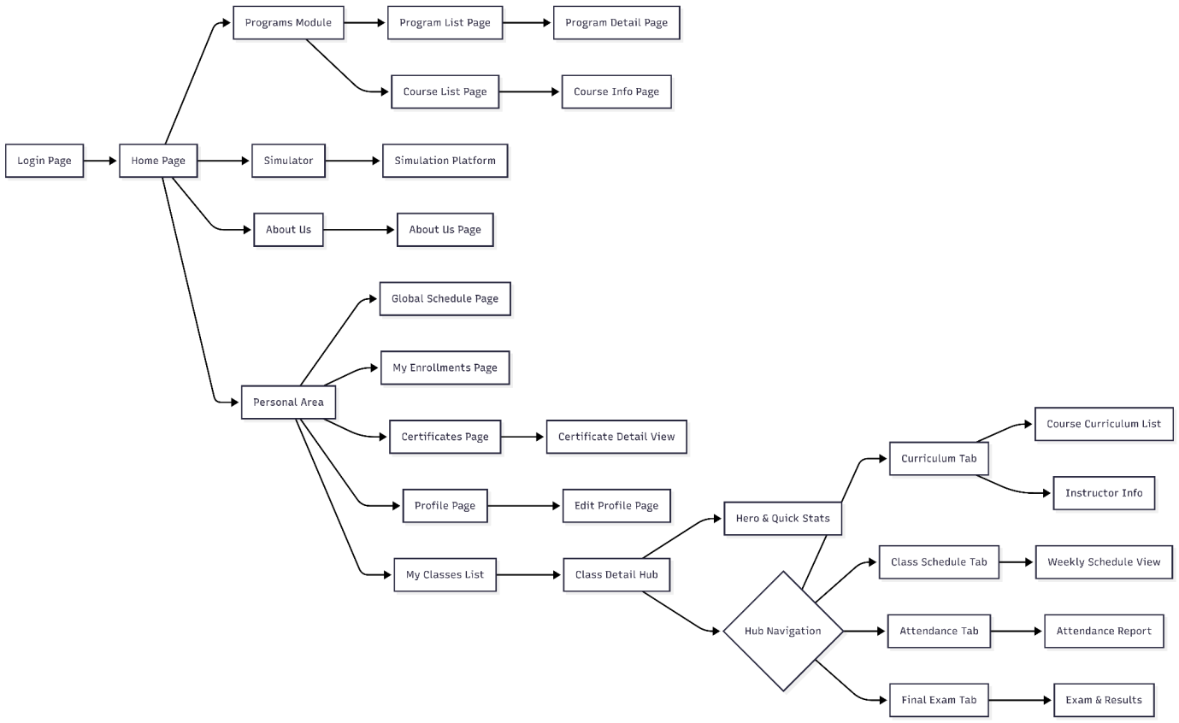

3.1.1.2 Instructor Flow
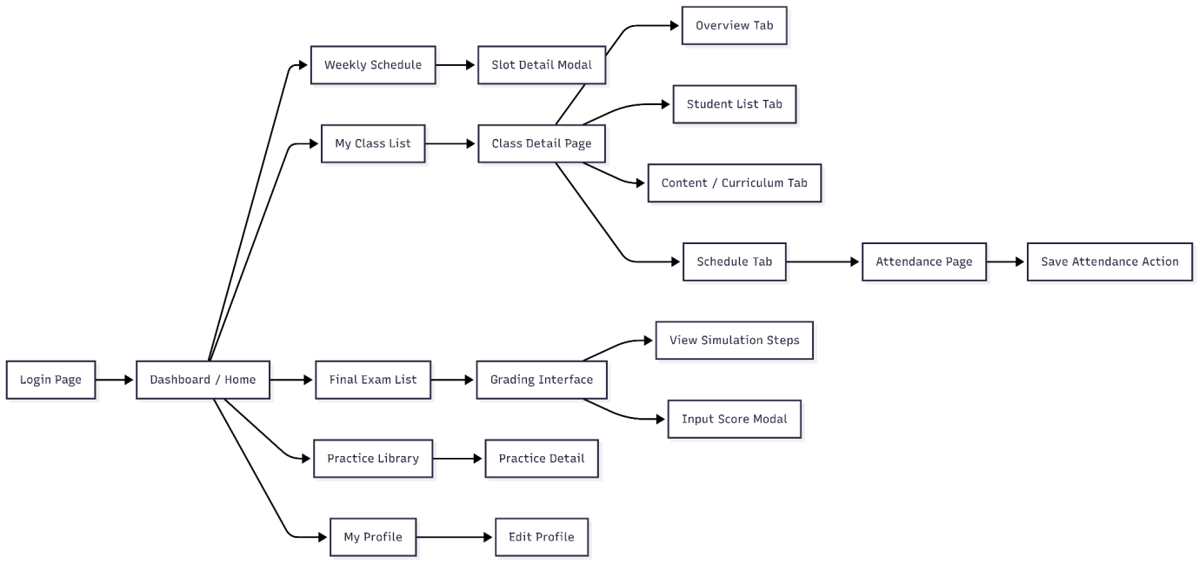

3.1.1.2 Simulation Manager Flow
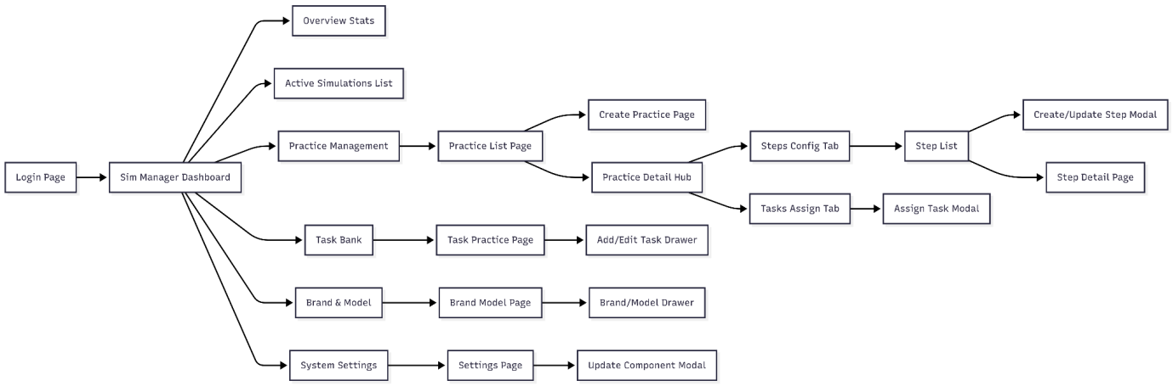

3.1.2 Screen Descriptions
# | Feature | Screen | Description
1 | Authentication | Login Screen | Allows users (Admin, Instructor, Trainee, Sim Manager) to log into the system using Email/Password or Google OAuth. Supports a link to the "Forgot Password" page.
2 | Authentication | Forgot Password Screen | Allows users to request a password reset via email verification and enter a new password.
3 | Common | Landing Page / Home | Introductory page for the training center, displaying featured courses, featured instructors, and related news. Visible to unauthenticated users or Trainees.
4 | Common | User Profile Screen | Allows users to view and update personal information, profile pictures, and change their password.
5 | Admin | Admin Dashboard | Displays a statistical overview of the system: total users, class statuses, course completion rates, and role distribution charts.
6 | Admin | User Management Screen | Lists all users in the system. Admins can add new users, edit details, disable accounts, or Import lists from Excel files.
7 | Admin | Program Management Screen | Manages training programs (frameworks). Allows creating new programs, assigning courses to programs, and setting up hierarchical structures.
8 | Admin | Course Management Screen | Manages the list of courses. Admins can create new courses, set up content (Sections, Lessons), upload learning materials, and configure Quizzes.
9 | Admin | Class Management Screen | Manages active classes. Allows creating classes based on courses, scheduling sessions, assigning instructors, and adding trainees to classes.
10 | Admin | Certificate Template Screen | Allows Admins to design and manage certificate templates to be issued to trainees upon course completion.
11 | Instructor | Instructor Dashboard | Displays upcoming teaching schedules, statistics on the number of assigned classes, and the status of assignments/exams needing grading.
12 | Instructor | Teaching Schedule Screen | Displays a detailed weekly or monthly schedule of the instructor's teaching time slots.
13 | Instructor | My Classes Screen | Lists classes assigned to the instructor. Specific class details can be accessed from here for management.
14 | Instructor | Class Detail & Attendance Screen | Detailed management screen for a class: performing attendance checks per session, viewing the trainee list, and monitoring their learning progress.
15 | Instructor | Quiz & Question Bank Screen | Manages the multiple-choice question bank. Creates and configures Quizzes to assign to course content.
16 | Instructor | Grading Screen | Allows instructors to view trainee submissions/results (including theoretical exams and simulation results) and enter grades.
17 | Trainee | My Learning/Classes Screen | Displays the list of classes the trainee is enrolled in and the completion progress of each class.
18 | Trainee | Learning Player Screen | The main interface for trainees to watch video lectures, read PDF materials, or take Quizzes following the course curriculum.
19 | Trainee | Exam Taking Screen | Interface for taking multiple-choice exams (Final Exam/Quiz) with a countdown timer, question list, and submission function.

3.1.3 Screen Authorization
# | Screen | Admin | Instructor | Trainee | Sim Manager
1 | Landing Page / Home | x | x | x | x
2 | Login Screen | x
3 | Forgot Password Screen | x
4 | User Profile Screen |  | x | x | x
5 | Admin Dashboard |  | x
6 | User Management Screen |  | x
7 | Program Management Screen |  | x
8 | Course Management Screen |  | x
9 | Class Management Screen |  | x
10 | Certificate Template Screen |  | x
11 | Instructor Dashboard |  |  | x
12 | Teaching Schedule Screen |  |  | x
13 | My Classes Screen (Instructor) |  |  | x
14 | Class Detail & Attendance Screen |  |  | x
15 | Quiz & Question Bank Screen |  |  | x
16 | Grading Screen |  |  | x
17 | My Learning/Classes Screen (Trainee) |  |  |  | x
18 | Learning Player Screen |  |  |  | x

3.1.4 Non-Screen Functions
# | Feature | System Function | Description
1 | JWT Token Management | User login or API request. | Generates Access Tokens and Refresh Tokens containing user claims and roles. Validates token signature and expiration on every incoming HTTP request to ensure secure access.
2 | Password Hashing | User registration or password change. | Secures user passwords using HMACSHA512 hashing algorithms with unique salts before storing them in the database, preventing plain-text storage.
3 | Google OAuth Validation | "Login with Google" action. | Communicates directly with Google APIs to validate the IdToken received from the client, retrieving user profile information to authenticate or register the user automatically.
4 | Email Notification Service | Forgot Password request or System Alerts. | Generates dynamic HTML email content (e.g., OTP codes) and dispatches emails to users via an SMTP server configuration.
5 | Excel Data Import Processor | Admin uploads an Excel file. | Parses binary Excel files (.xlsx) to bulk import complex data structures such as User lists, Quiz Question banks, and Training Programs into the database.
6 | Cloud Storage Integration | User uploads media (Avatar, Materials). | Handles file uploads to Firebase Storage. It manages file naming to prevent conflicts and generates public download URLs for storage in the database.
7 | Auto-Grading Engine | Trainee submits a Quiz or Simulation task. | For Quizzes: Compares user answers with the answer key, calculates the final score, and determines Pass/Fail status.  For Simulation: Processes JSON telemetry data from the simulation client to evaluate safety violations and execution time.
8 | Class Status Automation | Scheduled task or Data change. | Automatically evaluates class schedules and progress to transition class statuses (e.g., automatically marking a class as Completed when the end date is passed and requirements are met).
9 | Data Cleanup Service | Scheduled maintenance. | Identifies and removes orphaned records, temporary files, or soft-deleted data to optimize database performance and storage usage.

3.1.5 Entity Relationship Diagram

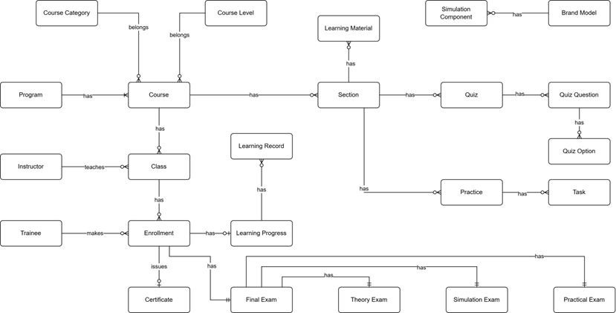

3.1.6 Entity Relationship Description
# | Entity | Description
1 | Course Category | Classification or categorization of courses by subject area or domain (e.g., Basic Crane Operations, Safety Procedures, Advanced Techniques). Provides organizational structure for grouping related courses. Each course belongs to one category.
2 | Course Level | Defines the difficulty or skill level of a course (e.g., Entry Level, Intermediate, Advanced). Used to establish learning progression paths and prerequisite requirements. Each course is assigned one level to indicate target trainee proficiency.
3 | Program | Comprehensive training program consisting of multiple courses designed to achieve specific certification or skill objectives. Programs define structured learning paths for trainees, combining courses in a logical sequence to build competencies for crane operator certification.
4 | Course | Individual training course representing a specific subject or skill area within the crane training curriculum. Contains course content structured into sections, can be assigned to multiple programs, and serves as the foundation for class creation. Belongs to one category and one level.
5 | Instructor | Teaching staff member responsible for delivering course instruction, managing class activities, creating learning materials and assessments, and evaluating trainee performance. Instructors are assigned to teach specific classes and provide guidance throughout the learning process.
6 | Class | Scheduled instance of a course with defined start/end dates, assigned instructor, and enrolled trainees. Represents the actual delivery of course content to a specific group of trainees. Classes are where learning activities, assessments, and instruction occur.
7 | Trainee | Student or learner enrolled in training programs to become certified crane operators. Trainees make enrollments in classes, access learning materials, complete quizzes and practices, take final exams, and track their learning progress toward certification.
8 | Enrollment | Record of a trainee's registration in a specific class. Creates the relationship between trainee and class, enabling access to course materials, activities, and assessments. Enrollment triggers creation of learning progress tracking and final exam records.
9 | Learning Material | Educational content resources such as videos, documents, presentations, or external links used to deliver course instruction. Materials are assigned to sections to provide trainees with reference and study resources. Can be reused across multiple sections.
10 | Section | Logical unit or module within a course syllabus representing a specific topic or learning objective. Sections organize course content into manageable chunks and contain learning materials, quizzes, and practices. Defines the structure and sequence of course curriculum.
11 | Quiz | Assessment tool containing multiple questions used to evaluate trainee understanding of theoretical concepts. Quizzes are assigned to sections, have defined pass criteria and time limits, and contribute to overall learning progress. Results are tracked through quiz attempts.
12 | Quiz Question | Individual question within a quiz presenting a problem or prompt for trainees to answer. Questions are assigned point values (contributing to total quiz score of 10 points) and can support single or multiple correct answers through associated quiz options.
13 | Quiz Option | Possible answer choice for a quiz question. Each option is marked as correct or incorrect and may have associated explanations. Multiple options per question enable various question types (multiple choice, select all that apply).
14 | Practice | Simulation-based training scenario performed in the 3D crane simulator environment. Practices consist of ordered tasks that trainees must complete to demonstrate hands-on skills. Assigned to sections as practical learning activities with defined difficulty levels and attempt limits.
15 | Task | Individual step or action within a simulation practice that trainees must perform correctly. Tasks define expected results for validation, and task completion is tracked during practice attempts. Tasks are reusable components across different practices.
16 | Simulation Component | 3D virtual representation of crane parts, controls, or environment objects used in simulation practices. Components are linked to brand models to represent real-world equipment and are referenced in tasks for interaction requirements.
17 | Brand Model | Specification of real crane equipment brands and models being simulated in the training system. Defines manufacturer information, specifications, and links to simulation components that represent the physical equipment in virtual environment.
18 | Learning Record | Historical record of trainee interactions with course sections, tracking what content has been accessed and when. Maintains audit trail of learning activities for compliance, reporting, and progress monitoring purposes.
19 | Learning Progress | Comprehensive tracking of trainee advancement through enrolled courses. Records overall progress percentage, theory and practical scores, completion status, and timestamps. Central entity for monitoring trainee performance and determining certification readiness.
20 | Certificate | Official document template awarded to trainees upon successful course or program completion. Defines certificate design, content structure, and requirements. Issued certificates are permanent records of trainee achievement for verification and credentialing purposes.
21 | Final Exam | Comprehensive assessment conducted at course completion to evaluate trainee readiness for certification. Consists of three components (Theory, Practical, Simulation) that are weighted and combined for total score. Results determine pass/fail status and certificate eligibility.
22 | Theory Exam | Written assessment component of final exam evaluating trainee understanding of theoretical concepts and safety knowledge. Implemented using the quiz system with defined pass criteria. One of three partial exams that compose the final exam.
23 | Simulation Exam | Performance-based assessment component conducted in 3D simulator requiring trainees to demonstrate crane operation skills. Uses practice system with task-by-task evaluation. One of three partial exams contributing to final exam score and certification decision.
24 | Practical Exam | Hands-on assessment component where trainees demonstrate physical crane operation skills evaluated by instructors using predefined checklists. Assesses real-world competencies beyond simulation environment. One of three partial exams required for certification.

3.2 Feature 1: Trainee Learning & Progress Tracking
3.2.1 Description
This is the core functional area for Trainees. It provides an interactive Learning Management System (LMS) interface where trainees perform their daily training activities. The system delivers multimedia content (Videos, PDFs), conducts assessments (Quizzes), and provides specifications for Simulation tasks. Crucially, it tracks the trainee's progress in real-time, ensuring they follow the structured curriculum path defined by the administration.
3.2.2 Functional Requirements
ID | Require | Description
FR-LRN-01 | Access My Classes | Trainees can view a list of all classes they are currently enrolled in, along with the current completion percentage and status (OnGoing, Completed) for each class.
FR-LRN-02 | View Course Curriculum | Within a class, the system displays the full hierarchy of the course: Sections (Modules) and Activities (Lessons). It indicates which activities are completed, in progress, or locked.
FR-LRN-03 | Multimedia Player | The system provides an embedded player to view MP4 video lectures and a PDF viewer for reading training manuals and safety guidelines directly within the browser.
FR-LRN-04 | Take Section Quizzes | Trainees can attempt quizzes assigned to specific sections. The system records the attempts, scores, and pass/fail status. Infinite or limited retakes are enforced based on configuration.
FR-LRN-05 | Simulation Task Guidance | For simulation activities, the web portal displays the task objectives, step-by-step instructions, and passing criteria (e.g., "Move container A to B within 5 minutes"), guiding the trainee before they enter the 3D simulator.
FR-LRN-06 | Automatic Progress Tracking | The system automatically marks activities as "Completed" when specific conditions are met (e.g., video watched 90%, PDF scrolled to bottom, Quiz passed).
FR-LRN-07 | Sequential Learning Enforcement | The system enforces a linear learning path (if configured), locking subsequent sections until the trainee has completed the prerequisite activities in the current section.
FR-LRN-08 | View Personal Profile & History | Trainees can view their own activity history, including past quiz scores, simulation practice results, and attendance records.

3.2.3 Screen Flow & UI Components
The learning experience involves two primary screens:
- My Learning Screen (Dashboard):
  - UI: A grid view of ClassCard components.
  - Information: Class Name, Course Code, Instructor Name, Progress Bar (visual indicator of completion), and "Continue Learning" button.
- Learning Player Screen (The Classroom):
  - Layout: A split-screen layout (Sidebar on the left, Content Area on the right).
  - Sidebar: Displays the CourseSection list (Accordion style). Icons indicate the type of activity (Video, Doc, Quiz) and its status (Green Check for done, Lock icon for locked).
  - Content Area:
    - Video: Uses a custom video player wrapper (VideoContent.jsx).
    - Document: Embeds a PDF viewer (ReadingContent.jsx).
    - Quiz: Renders the quiz interface (QuizContent.jsx) with question navigation.
    - Practice: Shows simulation task details and history of attempts (PracticeContent.jsx).

3.2.4 Backend Implementation Logic
The backend manages state tracking and content delivery:
- Controllers:
  - ProgressController: Aggregates data to calculate the overall percentage (LearningProgress).
  - ActivityRecordsController: Handles the granular status of each item (e.g., POST /api/activity-records to mark a video as watched).
  - SectionRecordsController: Monitors the completion of entire sections to unlock new content.
- Entities:
  - ActivityRecord: The pivotal entity linking a Trainee, a Class, and a specific Activity. It stores Status (Completed/Incomplete) and timestamps.
  - LearningMaterial: Stores the URL (Firebase) and metadata for the content.
- Business Logic:
  - Progress Calculation: ProgressesService.cs calculates progress as: (Count of Completed Activities / Total Activities in Course) * 100.
  - State Transition: When a Trainee passes a Quiz, the QuizAttemptsService triggers an update to the ActivityRecord, setting it to Completed.
  - Security: Content URLs are often signed or verified to prevent unauthorized access outside the learning platform.

3.3 Feature 2: Trainee Simulation Practice
3.3.1 Description
This feature bridges the gap between theoretical knowledge and real-world application. It allows Trainees to engage in practical crane operation exercises within a safe, physics-based 3D virtual environment. Unlike the Final Exam, these practices are part of the regular course curriculum (Learning Path). The system provides detailed scenario guides, tracks every movement and safety violation (collisions, dangerous swaying), and provides immediate automated grading and feedback.
3.3.2 Functional Requirements
ID | Require | Description
FR-SIM-01 | View Practice Objectives | Before starting, the Trainee can view the specific tasks required for the session (e.g., "Lift the red container," "Navigate through the obstacle course") and the criteria for passing (e.g., "Complete within 10 minutes").
FR-SIM-02 | Launch Simulation | The system initializes the 3D simulation environment directly within the browser (WebGL) or authenticates the user into a desktop client using a generated session token.
FR-SIM-03 | Real-time Telemetry Tracking | While practicing, the simulation client tracks critical metrics: execution time, collision counts (crane-to-obstacle, load-to-ground), and limit switch violations.
FR-SIM-04 | Step-by-Step Guidance | The system highlights the active task in the UI (e.g., "Step 1: Move to Point A"), updating automatically as the trainee completes actions in the 3D world.
FR-SIM-05 | Automatic Submission & Grading | Upon finishing the scenario or running out of time, the system automatically submits the performance data. The backend calculates a score (0-100) based on pre-defined penalties for safety violations.
FR-SIM-06 | View Attempt History | Trainees can view a history of their attempts for a specific practice module, allowing them to track improvement in their scores and completion times over multiple tries.
FR-SIM-07 | Safety Violation Alerts | Immediate visual feedback is provided in the simulation HUD (Heads-Up Display) if a safety rule is violated (e.g., "Warning: Load Swinging").

3.3.3 Screen Flow & UI Components
The feature utilizes an integrated approach within the Learning Player:
- Practice Overview Screen (LMS View):
  - Location: Inside the Learning Player Screen (see Feature 5).
  - Components:
    - Task List: Displays the sequence of PracticeTask items.
    - Stats Panel: Shows Allowed Time, Max Score, and Passing Score.
    - History Table: Uses PracticeAttemptsHistory.jsx to list previous attempts (Date, Duration, Score, Status).
    - Action: "Start Practice" button launches the simulation.
- Simulation Platform Screen (Active State):
  - UI: Full-screen or embedded 3D Canvas (SimulationPlatform.jsx).
  - HUD Elements:
    - Dashboard: Shows simulated crane indicators (wind speed, load weight, boom angle).
    - Notifications: Pop-ups for successful step completion or errors.
    - Controls: On-screen controls (if no hardware joystick is connected) or mapping overlay.

3.3.4 Backend Implementation Logic
The backend acts as the authoritative judge for the simulation results:
- Controllers:
  - PracticesController: Retrieves the scenario configuration (start positions, target zones) to initialize the 3D world.
  - PracticeAttemptsController: Handles the start (POST /start) and submission (POST /submit) of practice sessions.
- Entities:
  - Practice: Stores the metadata of the exercise.
  - PracticeTask: Defines the individual steps (e.g., "Lift", "Move", "Place").
  - PracticeAttempt: Stores the result of a single session.
- Grading Algorithm (PracticeAttemptsService.cs):
  - The system receives a SubmitPracticeTaskDto containing telemetry.
  - Base Score: Starts at 100 (or max defined).
  - Deductions: Subtracts points for:
    - Collisions (Severity * Penalty Weight).
    - Time Overrun (Time exceeded * Penalty per second).
    - Dangerous Operations (e.g., moving while load is too low).
  - Pass/Fail: Updates the ActivityRecord status based on whether the final score meets the PassScore threshold.

3.4 Feature 3: Program & Course Management
3.4.1 Description
This feature serves as the academic backbone of the LSSCTC system. It empowers Administrators to construct and organize the educational hierarchy. The system allows for the creation of Training Programs (curriculum frameworks) and individual Courses. Furthermore, it enables the detailed structuring of course content into Sections and specific Activities (Lessons, Videos, PDFs, Quizzes), effectively digitizing the crane training curriculum.
3.4.2 Functional Requirements
ID | Requirement | Description
FR-PROG-01 | Manage Training Programs | Admins can create, update, delete, and view Training Programs. A program acts as a container for multiple related courses (e.g., "Basic Crane Operation Program").
FR-PROG-02 | Program Hierarchy & Assignment | The system allows Admins to assign specific Courses to a Program. It maintains the relationship between programs and courses to structure the learning path.
FR-COURSE-01 | Manage Courses | Admins can manage the lifecycle of a Course, defining its title, description, level (Beginner/Intermediate/Advanced), and category.
FR-COURSE-02 | Curriculum Builder | The system provides an interface to structure a Course into Sections (Modules) and Activities (Lessons). Admins can arrange the order of learning content.
FR-MAT-01 | Learning Materials Management | Admins can upload and manage digital learning resources. Supported formats include PDF documents for reading and MP4 videos for lectures.
FR-MAT-02 | Cloud Storage Integration | The system integrates with Firebase Storage to securely upload and serve large media files (videos/documents), ensuring scalability and fast access.
FR-QUIZ-01 | Quiz Assignment | Admins can attach Quizzes (created in the Quiz Management feature) to specific sections within a course to assess trainee understanding.
FR-IMP-01 | Bulk Import Programs | The system supports importing complex program structures (Program -> Course -> Section) via Excel files to speed up initial data entry.

3.4.3 Screen Flow & UI Components
The management flow involves the following key screens:
- Program Management Screen:
  - UI: A list view of existing programs with options to "Add New Program" or "Import from Excel".
  - Action: Clicking on a program redirects to the Program Detail View, where linked courses are listed.
- Course Management Screen:
  - UI: Displays a catalog of all courses. Filters available by Category and Status (Active/Inactive).
  - Components: "Create Course" modal collecting basic info (Name, Code, Image).
- Course Detail & Curriculum Editor:
  - UI: A hierarchical view (often an Accordion or Tree view) displaying Sections.
  - Actions:
    - Add Section: Create a new topic/module.
    - Add Activity: Within a section, the Admin selects the type of activity: Video, PDF, or Quiz.
    - Upload: Drag-and-drop zone for uploading course materials.
3.4.4 Backend Implementation Logic
The backend handles the hierarchical data structure and file operations:
- Controllers:
  - ProgramsController: Manages the high-level program entities.
  - CoursesController: Handles course metadata.
  - SectionsController: Manages the subdivisions within a course.
  - MaterialsController & ActivitiesController: Handle the specific learning content.
- Services & Patterns:
  - Onion Architecture: Separates the domain entities (TrainingProgram, Course, Section) from the business logic.
  - Firebase Storage Service: The FirebaseStorageService.cs is invoked when uploading course materials. It returns a public URL which is then stored in the SQL Database.
  - Import Logic: ProgramImportService.cs uses NPOI to parse Excel files, automatically creating the necessary database relationships (Program-Course-Section) in a single transaction.
- Data Integrity:
  - The system enforces foreign key constraints to ensure that if a Course is deleted, related Enrollments or Sections are handled appropriately (Soft Delete pattern).

3.5 Feature 4: Trainee Final Examination
3.5.1 Description
The Final Examination feature is the culmination of the training process. To ensure comprehensive competency, the system evaluates Trainees through three distinct Final Exam Partials:
- Theory Exam (TE): A computer-based multiple-choice test with a strict time limit.
- Simulation Exam (SE): A practical test performed in the 3D Simulation Platform, graded automatically by the system based on safety and precision.
- Practical Exam (PE): An offline, real-world crane operation test graded by an Instructor using a digital checklist.
The system aggregates scores from these three partials based on pre-configured weights to determine the final Pass/Fail status.
3.5.2 Functional Requirements
ID | Require | Description
FR-EXAM-01 | View Exam Structure | The Trainee can view the Final Exam dashboard, which lists the three partials (TE, SE, PE), their current status (Locked, Open, Completed), and their weightage (e.g., 30%, 40%, 30%).
FR-EXAM-02 | Take Theory Exam (TE) | The system allows the Trainee to start the TE. The interface enables answering questions, flagging questions for review, and navigating between questions.
FR-EXAM-03 | TE Timer Enforcement | A server-side and client-side countdown timer enforces the exam duration. The system automatically submits the exam when the timer reaches zero.
FR-EXAM-04 | TE Auto-Grading | Upon submission, the system immediately calculates the score based on the answer key stored in the database and updates the TE status to "Completed".
FR-EXAM-05 | Generate Simulation Code (SE) | To take the Simulation Exam, the Trainee must request a unique, time-sensitive Exam Code via the web portal. This code is used to authenticate within the separate 3D Simulation Client.
FR-EXAM-06 | Process Simulation Results | The system receives telemetry data (collisions, time taken, load handling) from the 3D Client, calculates a score (0-100), and updates the SE record in the web portal.
FR-EXAM-07 | View Practical Results (PE) | Trainees cannot "take" the PE online. Instead, they view the grades and feedback checklist submitted by the Instructor after their real-world assessment.
FR-EXAM-08 | Final Grading Calculation | Once all partials are graded, the system calculates the weighted average. If the score meets the threshold, the Final Exam status is updated to Passed.

3.5.3 Screen Flow & UI Components
The examination flow is managed through the Final Exam Dashboard and specific execution screens:
- Final Exam Dashboard:
  - UI: A tabbed interface (IndustrialTabs) separating TE, SE, and PE.
  - Information: Displays current score, status badge (e.g., "In Progress"), and "Start" buttons (if applicable).
  - Logic: Locks specific tabs if the Class Schedule indicates the exam date has not arrived.
- Exam Taking Screen (TE):
  - Components:
    - Header: Countdown Timer (HeaderTimer.jsx), Progress Bar.
    - Body: Question Text, Option Radio Buttons (QuestionCard.jsx).
    - Sidebar: Grid of question numbers color-coded by status (Answered, Flagged, Unseen) (QuestionSidebar.jsx).
  - Action: "Submit Exam" button triggers a confirmation modal (SubmitModal.jsx).
- Simulation Exam View (SE):
  - UI: Informational card explaining the scenario.
  - Action: "Generate Exam Code" button.
  - Display: Shows the 6-digit code needed to login to the Unity Simulation.
- Exam Result View:
  - UI: Shows the score (e.g., "85/100"), the outcome ("Passed"), and a breakdown of correct/incorrect answers (for TE).
3.5.4 Backend Implementation Logic
The backend uses a complex relational structure to manage these diverse exam types:
- Entities:
  - FinalExam: The root entity linking a Trainee to a Class.
  - FinalExamPartial: Represents the specific instance of a TE, SE, or PE.
  - FeTheory: Stores specific data for TE (Quiz ID, Answers).
  - FeSimulation: Stores specific data for SE (Exam Code, Safety Violations).
  - PeChecklist: Stores the Instructor's evaluation for PE.
- Services (Lssctc.ProgramManagement):
  - FEService.cs: The orchestrator. It checks if the trainee is eligible to take the exam (Enrollment Status = Approved) and aggregates the final result.
  - FEPartialService.cs: Manages the lifecycle of a specific partial (e.g., checking if EndTime has passed).
  - SEService.cs: Specifically handles the logic for Simulation. It generates a random alphanumeric code and stores it in the FeSimulation table. When the 3D Client sends results, this service validates the code and saves the score.
  - QuizAttemptsService.cs: Reused for the Theory Exam to handle question randomization and scoring logic.
- Safety & Integrity:
  - TE: Preventing "tab switching" or multiple submissions is handled via browser events and backend validation of IsSubmitted flags.
  - SE: The Exam Code is valid only for a specific TimeSlot, preventing trainees from practicing simulations at home and counting it as an exam.

4. Non-Functional Requirements

4.1 Security
- NFR-SEC-01 (Authentication): The system must use JWT (JSON Web Tokens) for stateless, secure API authentication.
- NFR-SEC-02 (Token Management): The system must support token revocation (blacklist) using Distributed Cache to prevent usage of compromised tokens before expiry.
- NFR-SEC-03 (Data Protection): Sensitive data (like passwords) must be hashed. The API must communicate over HTTPS (though RequireHttpsMetadata is currently false for dev, production requires true).
- NFR-SEC-04 (Access Control): API endpoints must be protected by Role-Based Authorization policies ensuring users can only access data pertinent to their role.

4.2 Performance & Scalability
- NFR-PERF-01: The system uses Distributed Memory Cache to handle high-frequency data access like token validation and OTP storage.
- NFR-PERF-02: Database interactions must use asynchronous operations (async/await) to prevent thread blocking under load.
- NFR-PERF-03: Large data sets (Users, Classes, Enrolments) must be returned via Pagination (Paged Result) to reduce network payload and database load.

4.3 Interoperability & Compatibility
- NFR-INT-01: The API must expose a Swagger/OpenAPI documentation interface for client integration.
- NFR-INT-02: The system must support CORS (Cross-Origin Resource Sharing) to allow requests from specific web clients (e.g., lssctc.site, localhost).
- NFR-INT-03: The system must support standard file formats for imports/exports, specifically Excel (.xlsx) and CSV.

4.4 Availability & Reliability
- NFR-REL-01: The system is built on .NET Core and Entity Framework Core, designed for cross-platform deployment.
- NFR-REL-02: External integrations (e.g., Email Service) must be implemented as Transient services to ensure fresh connections and reliability.

5. Business Rules
ID | Rule Definition
BR-01 | Upon successful login to the web app, the system must redirect users to their role-based landing page:  - Admin: Admin Dashboard  - Simulation Manager: Simulation Manager Dashboard  - Instructor: Instructor Dashboard  - Trainee: Trainee Home Page
BR-02 | Upon successful login to the simulation app, users with the 'Trainee' role must be redirected to the home screen.
BR-03 | Deactivated accounts cannot log in or interact with the system.
BR-04 | The Username, Email, and Phone Number fields must be unique for each user account.
BR-05 | A user's Phone Number must be between 4 and 15 digits.
BR-06 | The Email field must adhere to a standard email format (e.g., user@domain.com).
BR-07 | A user's account profile can only be updated by the account owner.
BR-07 | A password reset request must require email verification.
BR-08 | The 'Admin' role has exclusive permissions to manage 'Simulation Manager', 'Instructor', and 'Trainee' accounts.
BR-09 | The 'Admin' role has exclusive permissions to:  - Create and update programs.  - Assign courses to a program.  - Create and update courses.  - Create and update course syllabi.  - Manage classes.
BR-10 | Instructors can only manage content for classes to which they are assigned.
BR-11 | A new program must be created with a Name and an Active Status.
BR-12 | A program cannot contain duplicate course assignments.
BR-13 | A program cannot be assigned more than 10 courses.
BR-14 | Each course must have a unique Name and a unique Course Code.
BR-15 | A new course must be created with a Name, Course Code.
BR-16 | A course’s learning section can only be updated if no classes are currently assigned to that course.
BR-17 | Each class must have a unique Name and a unique Class Code.
BR-18 | A class must be linked to a specific course upon creation.
BR-19 | A class must have exactly one assigned 'Instructor'.
BR-20 | Before a class starts, its learning content must mirror the learning sections of its parent course.
BR-21 | Class content can only be updated when class status is ‘Draft’ or ‘Open’.
BR-22 | A class can only be started if all conditions are met:  - At least one 'Trainee' is enrolled.  - One 'Instructor' is assigned only.  - Every class section contains at least one activity.
BR-23 | Each class must have a unique Name and a unique Class Code.
BR-24 | A 'Trainee' must have a valid account before enrolling in any program.
BR-25 | A 'Trainee' cannot be enrolled in the same class more than once.
BR-26 | A 'Trainee' cannot be enrolled in two different classes that have conflicted schedules.
BR-27 | 'Trainees' can only attempt quiz and practice when their session is valid.
BR-28 | Each learning activity must be one of the following types: 'Material', 'Quiz', or 'Practice'.
BR-29 | A new activity must be created with a Name, Type, and Order (sequence) number.
BR-30 | A new learning material (e.g., 'Video', 'Document') must include a Name and either a Source File or Source URL.
BR-31 | A Source File for learning material cannot exceed 50MB in size.
BR-32 | A new quiz must be created with a Name and a Max Attempts value.
BR-33 | A quiz must contain one or more questions.
BR-34 | Each question must include answer options, and each option must be flagged as 'Correct' or 'Incorrect'.
BR-35 | A quiz cannot contain more than 100 questions.
BR-36 | A quiz question cannot have more than 20 answer options.
BR-37 | The total score for every quiz must be exactly 10 points.
BR-38 | The score of any single question must be greater than 0 and less than 10.
BR-39 | The sum of all question scores within a quiz must equal 10.
BR-40 | Only users with the 'Trainee' role can attempt a quiz.
BR-41 | Every quiz attempt by a 'Trainee' must be recorded.
BR-42 | A 'Trainee's' final quiz score must be determined by their latest attempt.
BR-43 | 'Trainees' cannot retake a quiz after reaching the Max Attempts limit.
BR-44 | A simulation practice must contain between 1 and 20 tasks.
BR-45 | Each practice task must have a unique ‘task_code’.
BR-46 | Each practice must have a unique ‘practice_code’.
BR-47 | A task cannot be assigned to a practice more than once.
BR-48 | A new practice task must be created with a Name, Description, and Task Code.
BR-49 | A new simulation practice must have a unique Name and a unique Practice Code.
BR-50 | A new simulation Component must have a unique Name, and a unique Component Code.
BR-51 | 'Trainees' must be authenticated before accessing a simulation practice.
BR-52 | 'Trainees' can only start practices that are marked as 'Active' and are part of their assigned class.
BR-53 | 'Trainees' must complete all simulation tasks to finish a practice.
BR-54 | While a 'Trainee' is taking a simulation practice:  - The system must display guides and step descriptions.  - The system must automatically advance to the next step upon successful completion of the current step.  - The system must record the result of every step for evaluation.
BR-55 | 'Trainees' cannot retake a simulation practice after reaching the Max Attempts limit.
BR-56 | 'Trainees' must be authenticated before accessing a simulation practice.
BR-57 | 'Trainees' can only start a simulation final exam after input a correct Exam Code.
BR-58 | 'Trainees' can only access to the simulation final exam belongs to their enrolled classes.
BR-59 | While a 'Trainee' is taking a simulation final exam:  - The system must display guides and step descriptions.  - The system must automatically advance to the next task upon successful completion of the current step.  - The system must record the result of every task for evaluation.
BR-60 | 'Trainees' cannot retake a simulation final exam after reaching the Max Attempts limit.
BR-61 | New user accounts registered via email must complete Email Verification (via OTP or Link) before access is granted.
BR-62 | Users with a status of Inactive or Banned must be blocked from logging into the system immediately, regardless of valid credentials.
BR-63 | A Class cannot be created or set to Open status if its parent Course does not have a complete structure (at least one Section, Activity, and associated Material/Quiz).
BR-64 | The Class EndDate must be strictly greater than the StartDate. The StartDate cannot be set more than 30 days in the past.
BR-65 | The Class Code must be unique across the entire system (case-insensitive) to prevent data conflicts.
BR-66 | A Class can only transition from Draft to Open status if it has at least one assigned Instructor and at least one defined TimeSlot.
BR-67 | The sum of question max score for a quiz must explicitly equal 100%.
BR-68 | Trainees can only self-enroll in classes that have the status Open. Enrollment is strictly disabled for classes in Draft, Completed, or Cancelled status.
BR-69 | The system must prevent enrollment if the current class size (count of Enrolled + Pending trainees) has reached the defined MaxCapacity.
BR-70 | A Trainee cannot enroll in a class if they already have an existing enrollment record with a status of Pending or Enrolled for that specific class.
BR-71 | Enrollment Status Default:  - Self-enrollment by Trainee defaults to Pending (requires approval).  - Manual addition by Staff/Instructor defaults to Enrolled (bypasses approval).
BR-72 | Sections of a specific course can only be edited if there is no active classes which are opened from that course.
BR-73 | Access to specific class activities is restricted if the class status is ‘Draft’, or ‘Cancelled’, or ‘Completed’
BR-74 | To start a strictly controlled assessment (e.g., Final Exam), the Trainee must input a valid, case-sensitive Exam Code provided by the Instructor.
BR-75 | Trainees are blocked from starting a Quiz or Practice session if their total attempts exceed the configured Max Attempts limit.
BR-76 | The Final Grade must be automatically recalculated by the system whenever a component score (Theory/Practice/Exam) is updated, based on the defined Class Weights.
BR-77 | A Certificate is automatically issued to a Trainee only when all the following conditions are met:  1. The Class status is set to Completed.  2. The Trainee's learning progress is set to Completed.  3. The Trainee's Final Exam is set to Completed and is graded as Pass.
BR-78 | Once a Certificate is issued and a Certificate Number (License ID) is generated, it cannot be modified or deleted unless the entire Enrollment record is reset by an Administrator.
BR-79 | The system determines a Trainee's fina examl result based on the weighted sum of: (Theory Exam Score * Weight) + (Practical Exam Score * Weight) + (Simulation Exam Score * Weight).
BR-80 | Once an Instructor submits the grades for the "Final Exam" column and marks the status as Completed, the scores are locked (Read-only) and cannot be edited.
BR-81 | File Type Constraint: The system must restrict file uploads for Learning Materials to specific formats: .pdf for documents and .mp4 for videos.
BR-82 | A Course cannot be deleted if it has any associated Classes.
BR-83 | When importing data (User, Course, or Class) via Excel/CSV:  1. The file structure must strictly match the system provided template.  2. If any row contains invalid data (e.g., invalid email format, duplicate code), the entire import batch must be rejected to prevent data inconsistency.
BR-84 | Trainees can only access Practice Simulations when authorized via the class session check, typically enforcing access only within the assigned period.
BR-85 | An Administrator cannot Delete their own account while logged in. They also cannot change their own Role.
BR-86 | If a User authenticated session expires, the system provides a new session based on valid token.
BR-87 | The sum of weight percentages for all Assessment components (Theory, Practical, and Simulation) within a single Class must strictly equal 100%. The system shall prevent saving grading configurations if the total weight deviates from this value.
BR-87 | An Instructor cannot be assigned to a Class TimeSlot if they are already scheduled for another Class during the same time interval. The system must validate instructor availability before confirming the assignment.
BR-88 | A Trainee is prohibited from enrolling in a new Class if its schedule overlaps with any TimeSlots of their currently active Classes. The system must detect and block conflicting enrollments.
BR-89 | A Trainee is considered to have "Completed" a class only if they meet both of the following conditions:  1. The Final Exam Grade meets or exceeds the system-defined passing threshold (e.g., ≥ 5.0).  2. Learning progress is marked as completed.
BR-90 | A Class cannot be deleted if it contains any enrolled Trainees.
BR-91 | A Trainee is restricted from participating in the Final Exam if their Enrollment Status is marked as "Cancelled" (due to excessive absence) or if they have not completed all mandatory prerequisites.
BR-92 | Once a Class status transitions to "Completed" or “Cancelled”, all associated Trainee grades and activity records shall become read-only. Instructors are restricted from modifying grades unless an Administrator explicitly re-opens the Class.
BR-93 | The system must automatically reject new enrollment requests for a Class once the count of enrolled Trainees reaches the defined MaxCapacity limit set during Class creation.
BR-94 | The total weight percentage of all final exam assessments (Theory, Practical, and Simulation) within a specific Class must exactly equal 100%. The system shall prevent the Instructor or Admin from saving the configuration if the sum deviates from 100.
BR-95 | The system must restrict the deletion of any Course, Program, or Class if there are currently active Enrollments or associated Historical Data (e.g., Grades, Attendance records) linked to them to preserve data integrity.
BR-96 | The final exam session of a specific class can only be opened and closed by the assigned instructors.
BR-97 | For Simulation Exams, the system must follow the maximum number of attempts (e.g., 1 attempt for Final Exam). Any further attempts must be blocked.
BR-98 | For Theory Exams, the system must follow the maximum number of attempts (e.g., 1 attempt for Final Exam). Any further attempts must be blocked.
BR-99 | For Practical Exams, the overall status can only be graded as ‘Pass’ if more than half the checklists are passed.
BR-100 | The system shall only generate a downloadable Certificate (PDF) for a Trainee when the Class Status is "Completed" and trainee passes the final exam.
BR-101 | Once a user account is created or deactivated, the system must send a notification email to that user.
BR-102 | Once a class status is changed, the system must send a notification email to assigned instructors and trainees.
BR-103 | All system timestamps (Start Date, End Date, Logs) are stored and processed in UTC.

